Thực hành Kiến trúc máy tính

Week 10

Vũ Ngọc Đức – 20225816

Assignment 1

.eqv SEVENSEG_LEFT 0xFFFF0011 # Dia chi cua den led 7 doan trai.

# Bit 0 = doan a;

# Bit 1 = doan b; ...

# Bit 7 = dau .

.eqv SEVENSEG_RIGHT 0xFFFF0010 # Dia chi cua den led 7 doan phai

.text

main:

li $a0, 0x7D # set value for segments

jal SHOW_7SEG_RIGHT # show

li $a0, 0x6 # set value for segments

jal SHOW_7SEG_LEFT # show

exit:

li $v0, 10

syscall

endmain:

#---------------------------------------------------------------

# Function SHOW_7SEG_LEFT : turn on/off the 7seg

# param[in] $a0 value to shown

# remark $t0 changed

#---------------------------------------------------------------

SHOW_7SEG_LEFT:

li $t0, SEVENSEG_LEFT # assign port's address

sb $a0, 0($t0) # assign new value

jr $ra

#---------------------------------------------------------------

# Function SHOW_7SEG_RIGHT : turn on/off the 7seg

# param[in] $a0 value to shown

# remark $t0 changed

#---------------------------------------------------------------

SHOW_7SEG_RIGHT:

li $t0, SEVENSEG_RIGHT # assign port's address

sb $a0, 0($t0) # assign new value

jr $ra

Mở Digital Lab Sim trong Tool, kết nối nó với MIPS, chạy và hiển thị kết quả

Vũ Ngọc Đức có MSSV 20225816, số 16 là số cần hiện ra

Assignment 2

.eqv SEVENSEG_LEFT 0xFFFF0011 # Dia chi cua den led 7 doan trai.

# Bit 0 = doan a;

# Bit 1 = doan b; ...

# Bit 7 = dau .

.eqv SEVENSEG_RIGHT 0xFFFF0010 # Dia chi cua den led 7 doan phai

.data

message: .asciiz "Nhap vao mot so nguyen: "

.text

main:

li $v0, 4

la $a0, message

syscall

li $v0, 5

syscall

move $s0, $v0

li $t2, 10

div $s0, $t2 #hi = s0 mod t2

mfhi $t1 #t1 = hi

case0r:

bne $t1, 0, case1r

li $a0, 0x3F

jal SHOW_7SEG_RIGHT

j defaultr

case1r:

bne $t1, 1, case2r

li $a0, 0x6

jal SHOW_7SEG_RIGHT

j defaultr

case2r:

bne $t1, 2, case3r

li $a0, 0x5B

jal SHOW_7SEG_RIGHT

j defaultr

case3r:

bne $t1, 3, case4r

li $a0, 0x4F

jal SHOW_7SEG_RIGHT

j defaultr

case4r:

bne $t1, 4, case5r

li $a0, 0x66

jal SHOW_7SEG_RIGHT

j defaultr

case5r:

bne $t1, 5, case6r

li $a0, 0x6D

jal SHOW_7SEG_RIGHT

j defaultr

case6r:

bne $t1, 6, case7r

li $a0, 0x7D

jal SHOW_7SEG_RIGHT

j defaultr

case7r:

bne $t1, 7, case8r

li $a0, 0x7

jal SHOW_7SEG_RIGHT

j defaultr

case8r:

bne $t1, 8, case9r

li $a0, 0x7F

jal SHOW_7SEG_RIGHT

j defaultr

case9r:

bne $t1, 9, defaultr

li $a0, 0x6F

jal SHOW_7SEG_RIGHT

j defaultr

defaultr:

sub $s0, $s0, $t1

div $s0, $t2 #lo = s0 / t2

mflo $t3 #t3 = lo

div $t3, $t2 #hi = t3 mod t2

mfhi $t1 #t1 = hi

case0l:

bne $t1, 0, case1l

li $a0, 0x3F

jal SHOW_7SEG_LEFT

j defaultl

case1l:

bne $t1, 1, case2l

li $a0, 0x6

jal SHOW_7SEG_LEFT

j defaultl

case2l:

bne $t1, 2, case3l

li $a0, 0x5B

jal SHOW_7SEG_LEFT

j defaultl

case3l:

bne $t1, 3, case4l

li $a0, 0x4F

jal SHOW_7SEG_LEFT

j defaultl

case4l:

bne $t1, 4, case5l

li $a0, 0x66

jal SHOW_7SEG_LEFT

j defaultl

case5l:

bne $t1, 5, case6l

li $a0, 0x6D

jal SHOW_7SEG_LEFT

j defaultl

case6l:

bne $t1, 6, case7l

li $a0, 0x7D

jal SHOW_7SEG_LEFT

j defaultl

case7l:

bne $t1, 7, case8l

li $a0, 0x7

jal SHOW_7SEG_LEFT

j defaultl

case8l:

bne $t1, 8, case9l

li $a0, 0x7F

jal SHOW_7SEG_LEFT

j defaultl

case9l:

bne $t1, 9, defaultl

li $a0, 0x6F

jal SHOW_7SEG_LEFT

j defaultl

defaultl:

li $v0, 10

syscall

endmain:

#---------------------------------------------------------------

# Function SHOW_7SEG_LEFT : turn on/off the 7seg

# param[in] $a0 value to shown

# remark $t0 changed

#---------------------------------------------------------------

SHOW_7SEG_LEFT:

li $t0, SEVENSEG_LEFT # assign port's address

sb $a0, 0($t0) # assign new value

jr $ra

#---------------------------------------------------------------

# Function SHOW_7SEG_RIGHT : turn on/off the 7seg

# param[in] $a0 value to shown

# remark $t0 changed

#---------------------------------------------------------------

SHOW_7SEG_RIGHT:

li $t0, SEVENSEG_RIGHT # assign port's address

sb $a0, 0($t0) # assign new value

jr $ra

Input: 2024

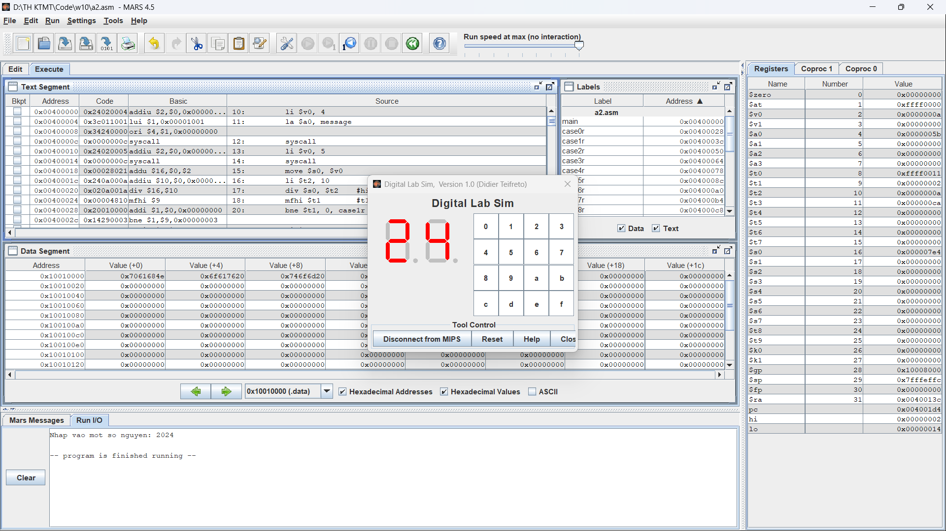

Input: 12

Assignment 3

.eqv SEVENSEG_LEFT 0xFFFF0011 # Dia chi cua den led 7 doan trai.

# Bit 0 = doan a;

# Bit 1 = doan b; ...

# Bit 7 = dau .

.eqv SEVENSEG_RIGHT 0xFFFF0010 # Dia chi cua den led 7 doan phai

.data

message: .asciiz "Nhap vao mot ky tu: "

.text

main:

li $v0, 4

la $a0, message

syscall

li $v0, 12

syscall

move $s0, $v0

li $t1, -1

convert:

addi $t1, $t1, 1

beq $s0, $t1, next

j convert

next:

move $s0, $t1

li $t2, 10

div $s0, $t2

mfhi $t1

case0r:

bne $t1, 0, case1r

li $a0, 0x3F

jal SHOW_7SEG_RIGHT

j defaultr

case1r:

bne $t1, 1, case2r

li $a0, 0x6

jal SHOW_7SEG_RIGHT

j defaultr

case2r:

bne $t1, 2, case3r

li $a0, 0x5B

jal SHOW_7SEG_RIGHT

j defaultr

case3r:

bne $t1, 3, case4r

li $a0, 0x4F

jal SHOW_7SEG_RIGHT

j defaultr

case4r:

bne $t1, 4, case5r

li $a0, 0x66

jal SHOW_7SEG_RIGHT

j defaultr

case5r:

bne $t1, 5, case6r

li $a0, 0x6D

jal SHOW_7SEG_RIGHT

j defaultr

case6r:

bne $t1, 6, case7r

li $a0, 0x7D

jal SHOW_7SEG_RIGHT

j defaultr

case7r:

bne $t1, 7, case8r

li $a0, 0x7

jal SHOW_7SEG_RIGHT

j defaultr

case8r:

bne $t1, 8, case9r

li $a0, 0x7F

jal SHOW_7SEG_RIGHT

j defaultr

case9r:

bne $t1, 9, defaultr

li $a0, 0x6F

jal SHOW_7SEG_RIGHT

j defaultr

defaultr:

sub $s0, $s0, $t1

div $s0, $t2

mflo $t3

div $t3, $t2

mfhi $t1

case0l:

bne $t1, 0, case1l

li $a0, 0x3F

jal SHOW_7SEG_LEFT

j defaultl

case1l:

bne $t1, 1, case2l

li $a0, 0x6

jal SHOW_7SEG_LEFT

j defaultl

case2l:

bne $t1, 2, case3l

li $a0, 0x5B

jal SHOW_7SEG_LEFT

j defaultl

case3l:

bne $t1, 3, case4l

li $a0, 0x4F

jal SHOW_7SEG_LEFT

j defaultl

case4l:

bne $t1, 4, case5l

li $a0, 0x66

jal SHOW_7SEG_LEFT

j defaultl

case5l:

bne $t1, 5, case6l

li $a0, 0x6D

jal SHOW_7SEG_LEFT

j defaultl

case6l:

bne $t1, 6, case7l

li $a0, 0x7D

jal SHOW_7SEG_LEFT

j defaultl

case7l:

bne $t1, 7, case8l

li $a0, 0x7

jal SHOW_7SEG_LEFT

j defaultl

case8l:

bne $t1, 8, case9l

li $a0, 0x7F

jal SHOW_7SEG_LEFT

j defaultl

case9l:

bne $t1, 9, defaultl

li $a0, 0x6F

jal SHOW_7SEG_LEFT

j defaultl

defaultl:

li $v0, 10

syscall

endmain:

#---------------------------------------------------------------

# Function SHOW_7SEG_LEFT : turn on/off the 7seg

# param[in] $a0 value to shown

# remark $t0 changed

#---------------------------------------------------------------

SHOW_7SEG_LEFT:

li $t0, SEVENSEG_LEFT # assign port's address

sb $a0, 0($t0) # assign new value

jr $ra

#---------------------------------------------------------------

# Function SHOW_7SEG_RIGHT : turn on/off the 7seg

# param[in] $a0 value to shown

# remark $t0 changed

#---------------------------------------------------------------

SHOW_7SEG_RIGHT:

li $t0, SEVENSEG_RIGHT # assign port's address

sb $a0, 0($t0) # assign new value

jr $ra

Input: A

Input: a

Assignment 4

.eqv MONITOR_SCREEN 0x10010000

.eqv GRAY 0x808080

.eqv WHITE 0xFFFFFF

.text

li $k0, MONITOR_SCREEN

li $s0, 2

li $t0, -1 # Khoi tao row

For1:

addi $t0, $t0, 1

beq $t0, 8, Exit

li $t1, -1 # Khoi tao column

For2:

addi $t1, $t1, 1

beq $t1, 8, EndFor2

div $t0, $s0

mfhi $t2

div $t1, $s0

mfhi $t3

bne $t2, 0, Next

bne $t3, 0, Paint2

j Paint1

Next:

beq $t3, 0, Paint2

Paint1:

sll $s1, $t0, 3

add $s1, $s1, $t1

sll $s1, $s1, 2

add $s2, $s1, $k0

li $t4, GRAY

sw $t4, 0($s2)

j For2

Paint2:

sll $s1, $t0, 3

add $s1, $s1, $t1

sll $s1, $s1, 2

add $s2, $s1, $k0

li $t4, WHITE

sw $t4, 0($s2)

j For2

EndFor2:

j For1

Exit:

li $v0, 10

syscall

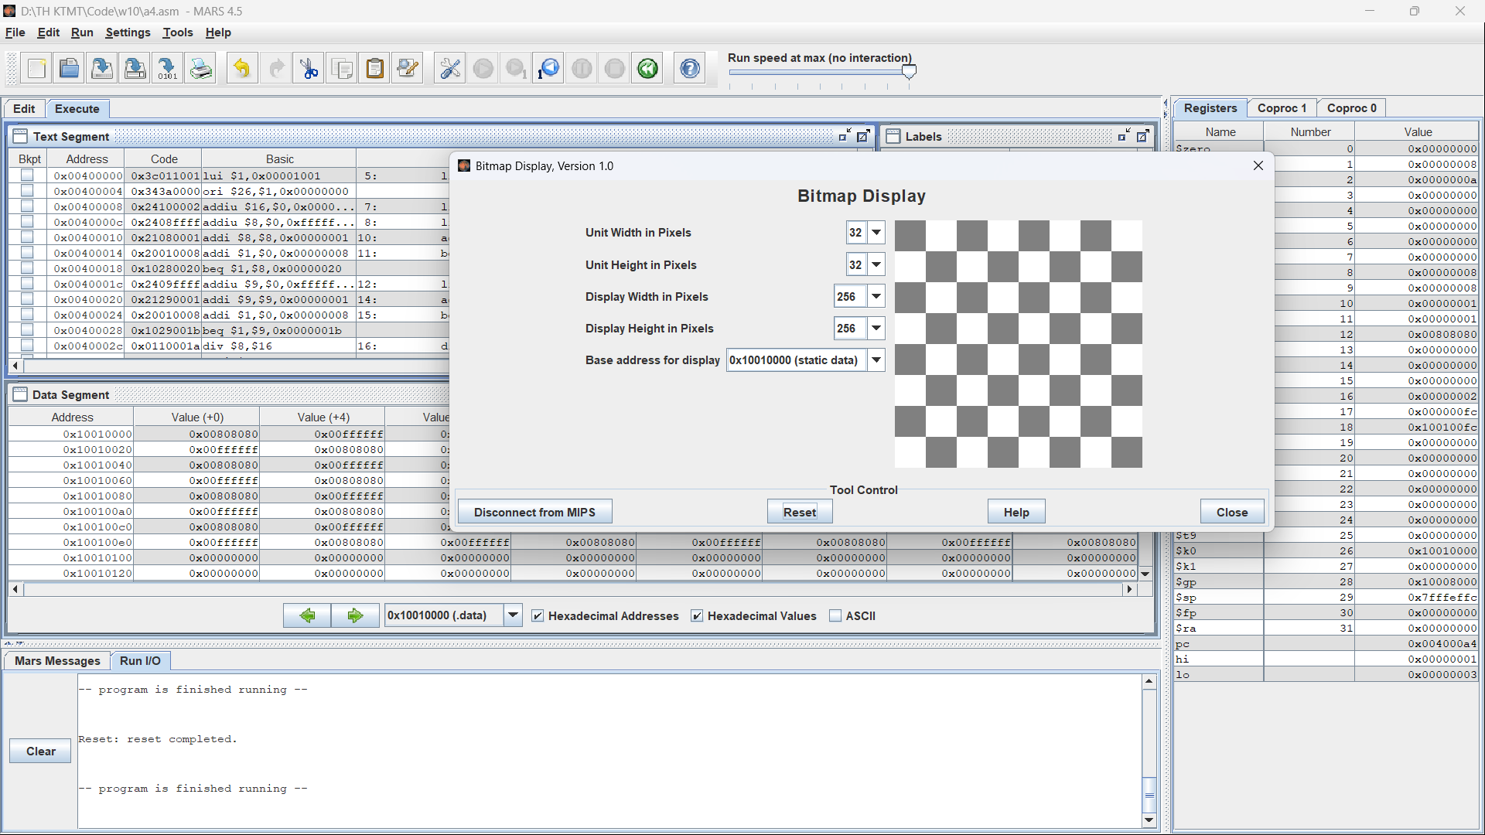

Assignment 5

.eqv MONITOR_SCREEN 0x10010000

.eqv RED 0x00FF0000

.eqv GREEN 0x0000FF00

.data

x1: .asciiz "Nhap x1: "

y1: .asciiz "Nhap y1: "

x2: .asciiz "Nhap x2: "

y2: .asciiz "Nhap y2: "

error1: .asciiz "Error: x2 phai khac x1. Moi nhap lai!\n"

error2: .asciiz "Error: y2 phai khac y1. Moi nhap lai!\n"

.text

li $k0, MONITOR_SCREEN

li $v0, 4

la $a0, x1

syscall

li $v0, 5

syscall

move $s0, $v0

li $v0, 4

la $a0, y1

syscall

li $v0, 5

syscall

move $s1, $v0

Inputx2:

li $v0, 4

la $a0, x2

syscall

li $v0, 5

syscall

move $s2, $v0

beq $s2, $s0, Error1

Inputy2:

li $v0, 4

la $a0, y2

syscall

li $v0, 5

syscall

move $s3, $v0

beq $s3, $s1, Error2

j Continue

Error1:

li $v0, 4

la $a0, error1

syscall

j Inputx2

Error2:

li $v0, 4

la $a0, error2

syscall

j Inputy2

Continue:

slt $t0, $s0, $s2

slt $t1, $s1, $s3

beq $t0, 0, Case3

beq $t1, 0, Case2

Case1:

add $v0, $s1, $zero

For1:

bgt $v0, $s3, Exit

add $v1, $s0, $zero

For2:

bgt $v1, $s2, EndFor2

beq $v0, $s1, InVien1

beq $v0, $s3, InVien1

beq $v1, $s0, InVien1

beq $v1, $s2, InVien1

sll $t8, $v0, 6

add $t8, $t8, $v1

sll $t8, $t8, 2

li $a1, GREEN

add $a2, $k0, $t8

sw $a1, 0($a2)

add $v1, $v1, 1

j For2

InVien1:

sll $t8, $v0, 6

add $t8, $t8, $v1

sll $t8, $t8, 2

li $a1, RED

add $a2, $k0, $t8

sw $a1, 0($a2)

add $v1, $v1, 1

j For2

EndFor2:

add $v0, $v0, 1

j For1

Case2:

add $v0, $s3, $zero

For3:

bgt $v0, $s1, Exit

add $v1, $s0, $zero

For4: bgt $v1, $s2, EndFor4

beq $v0, $s1, InVien2

beq $v0, $s3, InVien2

beq $v1, $s0, InVien2

beq $v1, $s2, InVien2

sll $t8, $v0, 6

add $t8, $t8, $v1

sll $t8, $t8, 2

li $a1, GREEN

add $a2, $k0, $t8

sw $a1, 0($a2)

add $v1, $v1, 1

j For4

InVien2:

sll $t8, $v0, 6

add $t8, $t8, $v1

sll $t8, $t8, 2

li $a1, RED

add $a2, $k0, $t8

sw $a1, 0($a2)

add $v1, $v1, 1

j For4

EndFor4:

add $v0, $v0, 1

j For3

Case3:

beq $t1, 0, Case4

add $v0, $s1, $zero

For5:

bgt $v0, $s3, Exit

add $v1, $s2, $zero

For6:

bgt $v1, $s0, EndFor6

beq $v0, $s1, InVien3

beq $v0, $s3, InVien3

beq $v1, $s0, InVien3

beq $v1, $s2, InVien3

sll $t8, $v0, 6

add $t8, $t8, $v1

sll $t8, $t8, 2

li $a1, GREEN

add $a2, $k0, $t8

sw $a1, 0($a2)

add $v1, $v1, 1

j For6

InVien3:

sll $t8, $v0, 6

add $t8, $t8, $v1

sll $t8, $t8, 2

li $a1, RED

add $a2, $k0, $t8

sw $a1, 0($a2)

add $v1, $v1, 1

j For6

EndFor6:

add $v0, $v0, 1

j For5

Case4:

add $v0, $s3, $zero

For7:

bgt $v0, $s1, Exit

add $v1, $s2, $zero

For8:

bgt $v1, $s0, EndFor8

beq $v0, $s1, InVien4

beq $v0, $s3, InVien4

beq $v1, $s0, InVien4

beq $v1, $s2, InVien4

sll $t8, $v0, 6

add $t8, $t8, $v1

sll $t8, $t8, 2

li $a1, GREEN

add $a2, $k0, $t8

sw $a1, 0($a2)

add $v1, $v1, 1

j For8

InVien4:

sll $t8, $v0, 6

add $t8, $t8, $v1

sll $t8, $t8, 2

li $a1, RED

add $a2, $k0, $t8

sw $a1, 0($a2)

add $v1, $v1, 1

j For8

EndFor8:

add $v0, $v0, 1

j For7

Exit:

li $v0, 10

syscall

Input: A(20;25), B(1;1)

